RESUME

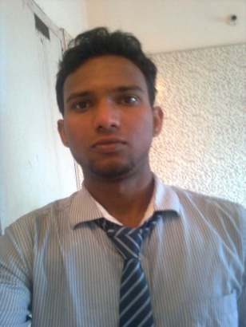

MANASH PROTIM BORTHAKUR
C/O-LATE DHANBOR GOGOI
House No.- 77
JAPORIGOG
Ganeshguri, Guwahati- 6
Mobile:- 8721803286(M)
Email-Id:- manashborthakur6@gmail.com

Career Objective

To work in a challenging atmosphere with the best of my skills and ability, where I can help achieve the organizational goal through my individual growth.
Educational Qualification

• HSLC from N.P. H.S. School in the year 2007.
Under(Board of Secondary Education, Assam)
• H.S. in Arts Stream from H.C.D.G in the year 2009
Under (Assam Higher Secondary Education Council
- B.A from Dibrughar university in the year of 2012

Professional Qualification

• Hardware and Networking Engineer Course from Jetking Institute, Guwahati.(A+, N+,MCITP, CCNA)
Experience
• Nill
Computer Knowledge

Operating System: DOS,Windows98,WindowsXP,Server2003,
Server 2008, .
Computer Packages: MS-Office (Word, Excel, Power point).
Hardware Knowledge: Assembling, troubleshooting & installing of PC.

Networking Knowledge: Setting up LAN, Internet Connection Sharing, Cabling, and Internetworking basics, TCP/IP, Basics of Router and Switch.

Personal Details

Father’s Name : Khirud Borthakur
Date of Birth : 11january 1990.
Permanent Address: Vill+P.O. Nitai Pukhuri, P.S:-
Demow Dist-Sivasagar
State-Assam, Pin- 785671

Marital Status : Single
Nationality : Indian
Gender : Male
Languages known : English, Hindi, Assamese.
Hobbies : Watching movies, Playing Cricket, Reading Books.

Streangth : Hardworking& Honesty

Declaration

I hereby declare that the information furnished above is true to the best of my knowledge and belief.

Date:

Place:
_______________________

manash protim borthakur

